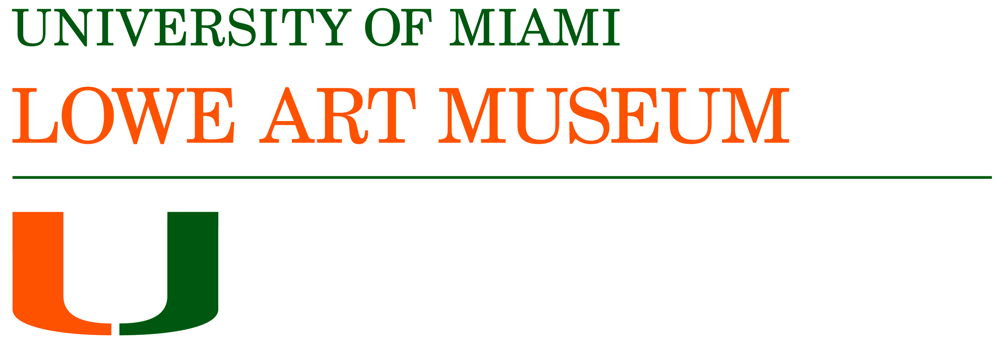
Media Contact:
Susanne Haase
Lowe Art Museum
msh119@miami.edu
305-284-5422

Lowe Art Museum and Miller School of Medicine Offer Residents a Workshop to Enhance Clinical Skills through Art Interpretation
The Lowe Gears Up for Patient Safety Week, June 18 to 22, 2018

Miami, FL, (May x, 2018) – More than two dozen first and second-year pediatric residents and two professors from University of Miami’s Miller School of Medicine recently visited the Lowe Art Museum to work on their observation and communication skills by interpreting works of art. Participating in small group workshops facilitated by the Lowe’s art education team, the students carefully examined and discussed a work of art and shared their ideas and perspectives openly, using critical skills they apply in clinical settings.
The workshops employ the Visual Thinking Strategies (VTS) teaching methodology that leads participants to slow down, observe, interpret, and share impressions of a work of art in an open, relaxed, and non-judgmental setting that fosters respectful dialog and tolerance for ambiguity. The participants also have the opportunity to facilitate a discussion themselves, providing them with a chance to hone their listening and communication skills, as well as reinforce the importance of teamwork.
“What takes place during the Fine Art of Health Care” workshops is so relevant to the work these students do in clinical situations, but without the stress and pressure that can sometimes compromise patient outcomes,” says Hope Torrents, education coordinator and director of the Fine Art of Health Care at the Lowe. “Here, they have a chance to mindfully observe and to link visual and verbal cues – skills that are critical to their work as clinicians.”
“We were so fortunate to have our pediatric resident physicians participate in the Lowe Art Museum's Fine Art of Healthcare program,” said Dr. Barry Gelman, director of pediatric residency training at the Holtz Children's Hospital/Jackson Memorial Medical Center and Associate Professor in the Department of Pediatrics at the University of Miami Miller School of Medicine. “Besides enjoying a relaxing day and each other's company at the museum, the residents learned to appreciate art in a novel and sophisticated way - by relating their experience of viewing, contemplating, and discussing works of art to the ‘art’ of clinical medicine.” He adds, “I foresee they will return to these lessons over and over again during their remaining training, and throughout their careers. They will be better observers, better history-takers, better listeners, and better diagnosticians. In short, better doctors.”
Patient Safety Week at the Lowe
The Fine Art of Health Care program will again be scheduled into University of Miami’s Patient Safety Week, from June 18 to 22 this year. As part of the program, more than 240 medical and nursing graduate students will spend the day in the Lowe on June 20 and participate in VTS workshops, designed to enhance patient outcomes.
The Fine Art of Health Care program began at the Lowe Art Museum nearly ten years ago and has been extended to law students, mental health care providers, and military veterans. It is exemplary of the inter-disciplinary collaboration that leverages UM’s resources and scholarship to benefit students and professionals in different areas of study and disciplines.
About Lowe Art Museum
The Lowe Art Museum (www.miami.edu/lowe) is located on the campus of the University of Miami at 1301 Stanford Drive, Coral Gables, Florida. With a permanent collection of 19,000 objects spanning 5,000 years of world culture, the Lowe is committed to serving as a vital resource for education and enrichment through art. Its dynamic permanent and temporary exhibitions establish the Lowe as a keeper of memories, a showcase for masterworks, an igniter of awe and wonder, and a bridge between yesterday and today.

Museum gallery hours are Tuesday to Saturday, 10 a.m. to 4 p.m. and Sunday, noon to 4 p.m. The Museum is closed on Mondays and University holidays. General Admission (not including programs) is $12.50, $8 for senior citizens and non-UM students, and free for Lowe members, UM students, faculty and staff, and children under 12. Admission is free on Donation Day, the first Tuesday of every month. For more information, call 305-284-3535, follow us on Twitter at @loweartmuseum, follow us on Facebook.com/loweartmuseum, or visit www.lowe.miami.edu.

Images from UM Miller School of Medicine Pediatric Residents
Fine Art of Health Care workshops at the Lowe, May 2018.
